Amethyst
Amethyst violet
A moderate violet natural amethyst spectrum obtained through 10 mm thick plate along an arbitrary direction.
 | RGB VALUES  R: 131  G: 100  B: 134 | 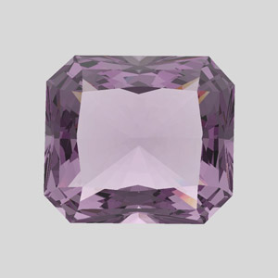
Corundum
Corundum Red - Ruby
A red synthetic corundum spectrum obtained through 10 mm thick plate along an arbitrary direction.
 | RGB VALUES  R: 093  G: 000  B: 021 | 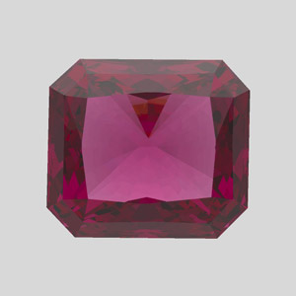
Corundum Red - Ruby
Spectrum of the same red material obtained through the 11 mm thick plate with another arbitrary direction. Red colour of that stone is related with Cr3+ adsorption features.
 | RGB VALUES  R: 123  G: 000  B: 046 | 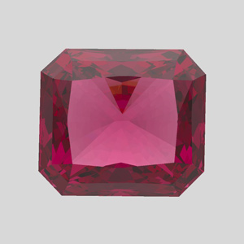

Corundum Orange Red - Ruby
An orange-red synthetic corundum spectrum obtained through 10 mm thick plate along an arbitrary direction.
 | RGB VALUES  R: 134  G: 026  B: 000 | 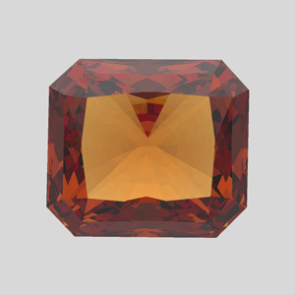
Corundum Orange Red - Ruby
Spectrum of the same material obtained through the 11.5 mm thick plate along another direction. Cr3+ features also present in spectrum of this stone, but the concentration of Cr is much lower.
 | RGB VALUES  R: 188  G: 086  B: 001 | 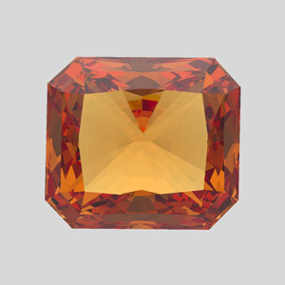
Corundum Orange - Ruby
An orange synthetic corundum spectrum obtained through 9 mm thick plate along an arbitrary direction.
 | RGB VALUES  R: 205  G: 122  B: 000 | 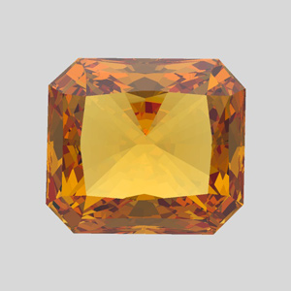
Corundum Orange - Ruby
Spectrum of the same material obtained through the 10 mm thick plate along another direction. No Cr3+ related features present. Colour origin of that stone is undefined.
 | RGB VALUES  R: 220  G: 148  B: 001 | 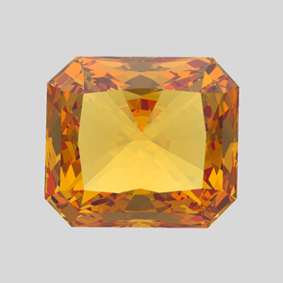
Cubic Zirconium
Cubic Zirconium Green
A green cubic zirconium (CZ) spectrum obtained through 18 mm thick plate. Colour of that stone is related with REE adsorption.
 | RGB VALUES  R: 180  G: 182  B: 059 | 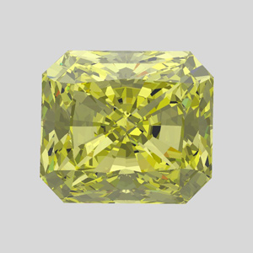
Cubic Zirconium Red
A red CZ spectrum obtained through 20 mm thick plate.
 | RGB VALUES  R: 188  G: 000  B: 000 | 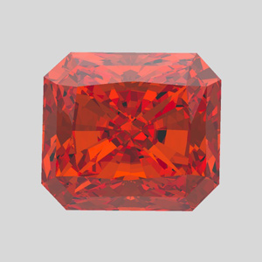
Cubic Zirconium Violet
A violet CZ spectrum obtained through 22 mm thick plate. Colour of that stone is related with REE adsorption.
 | RGB VALUES  R: 138  G: 106  B: 145 | 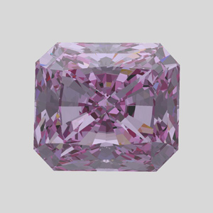
Cubic Zirconium Yellow
A yellow cubic zirconium (CZ) spectrum obtained through 4 mm thick plate. Colour of that stone is related with REE adsorption.
 | RGB VALUES  R: 202  G: 172  B: 000 | 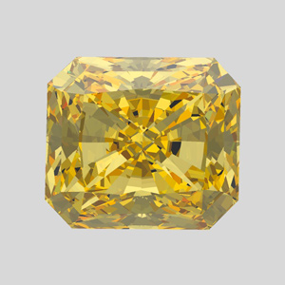
Diamond
Diamond - Black
A dark orange-brown natural diamond (untreated) spectrum obtained through 3.6 mm thick plate. This diamond is Ia type and it can be assumed that its colour is connected with dislocations.
 | RGB VALUES  R: 016  G: 000  B: 000 | 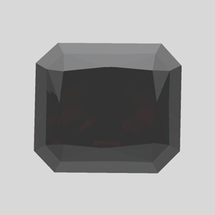
Diamond Fancy Deep Orange Brown - Champaign
A fancy deep orange-brown natural diamond (untreated) "Diamond_Fancy_Deep_Orange_ Brown" spectrum obtained through 4.15 mm thick plate. This diamond is Ia type and it is assumed that its colour is also connected with dislocations.
 | RGB VALUES  R: 152  G: 079  B: 000 | 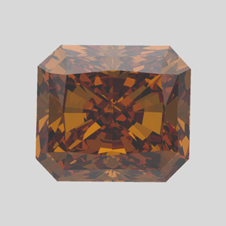
Diamond Fancy Yellow – Canary Yellow
A fancy yellow natural diamond (untreated) spectrum obtained through 4 mm thick plate. This diamond is natural Ib type and its colour is related with C-centres absorption.
 | RGB VALUES  R: 210  G: 193  B: 101 | 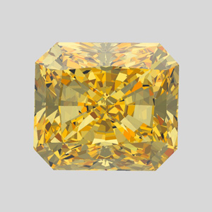

Diamond Fancy Yellow Lemon
A fancy greenish-yellow natural diamond (untreated) spectrum obtained through 6.76 mm thick plate. Colour of that stone is related with two broad bands on 478 and 560 nm.
 | RGB VALUES  R: 191  G: 175  B: 115 | 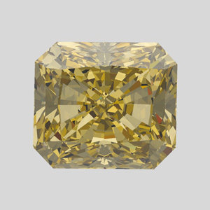
Diamond Yellow
A light yellow natural diamond spectrum obtained through 3.5 mm thick plate along a triad axis direction. This diamond is Ia type and its colour is related with N3-N2 centres.
 | RGB VALUES  R: 194  G: 193  B: 111 | 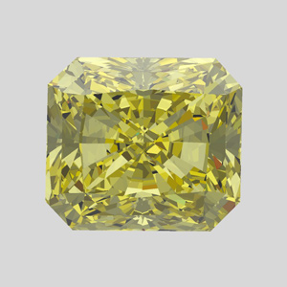
Sapphire
Sapphire
A blue natural sapphire "Sapphire" spectrum obtained from Mineral Spectroscopy Server visible spectra database* and then adjusted. Sapphire colour is related with Ti-Fe presence.
 | RGB VALUES  R: 000  G: 008  B: 063 | 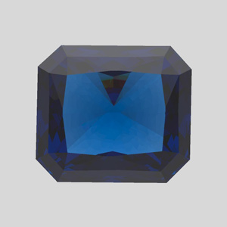

Emerald
Emerald
A green natural emerald spectrum is one of DiamCalc standard spectra. Emerald colour is related with Cr presence.
 | RGB VALUES  R: 000  G: 161  B: 112 | 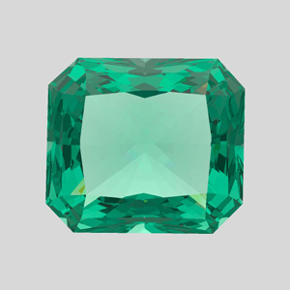
Synthetic diamond
Yellow synthetic diamond
A yellow synthetic diamond spectrum obtained through 5 mm thick plate. This diamond is Ib type and its colour is related with C-centres absorption.
 | RGB VALUES  R: 202  G: 148  B: 000 | 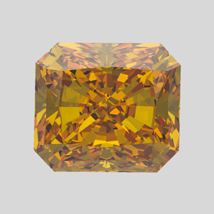
Topaz
Topaz parallel C-axis direction
A blue irradiated topaz "Topaz_paralC" spectrum obtained through 13 mm thick plate along parallel C-axis
 | RGB VALUES  R: 166  G: 191  B: 195 | 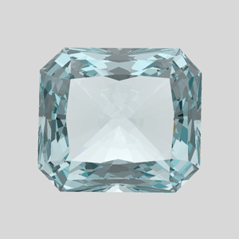

Topaz perpendicular C-axis direction
Spectrum of the same material obtained through the 11.5 mm thick plate in the perpendicular C-axis direction.
 | RGB VALUES  R: 183  G: 197  B: 200 | 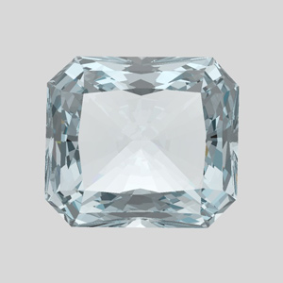
Quartz
Quartz through the zone with weaker colour
A yellow colour-treated natural quartz spectrum obtained through 12 mm thick plate perpendicular C-axis of the stone recorder through the zone with weaker colour.
 | RGB VALUES  R: 204  G: 194  B: 158 | 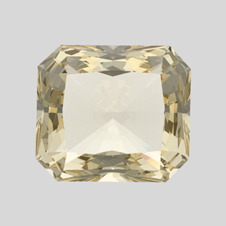
Quartz through the zone with more yellow colour
Spectrum of the same material obtained through the same plate but through the zone with more yellow colour. Colour of that stone is related with Fe3+ presence.
 | RGB VALUES  R: 214  G: 195  B: 137 | 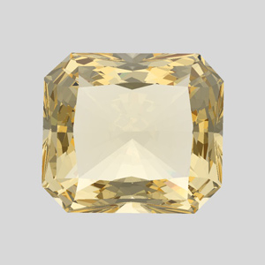

MY CUSTOM GEMS

Gem Name
Description……
 | RGB VALUES  R: 057  G: 040  B: 100 | 